**Exercise 3: Assertions in JUnit**

**Scenario:** You need to use different assertions in JUnit to validate your test results.

**STRUCTURE:**

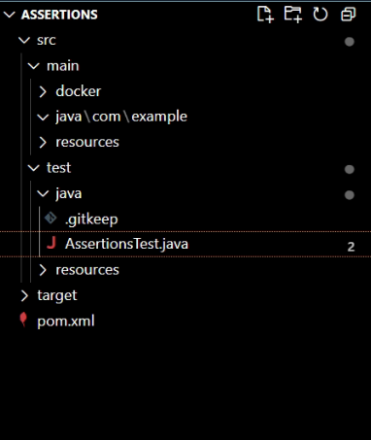

**assertions.java:**

package com.example;

import static org.junit.Assert.assertEquals;

import static org.junit.Assert.assertFalse; // Import all assertion methods

import static org.junit.Assert.assertNotNull;

import static org.junit.Assert.assertNull;

import static org.junit.Assert.assertTrue;

import org.junit.Test;

public class AssertionsTest {

@Test

public void testAssertions() {

// Assert equals

assertEquals(5, 2 + 3);

// Assert true

assertTrue(5 > 3);

// Assert false

assertFalse(5 < 3);

// Assert null

assertNull(null);

// Assert not null

assertNotNull(new Object());

}

}

**OUTPUT:**

